**Lab4 Report**

Following Screen shot represents the page of the android app.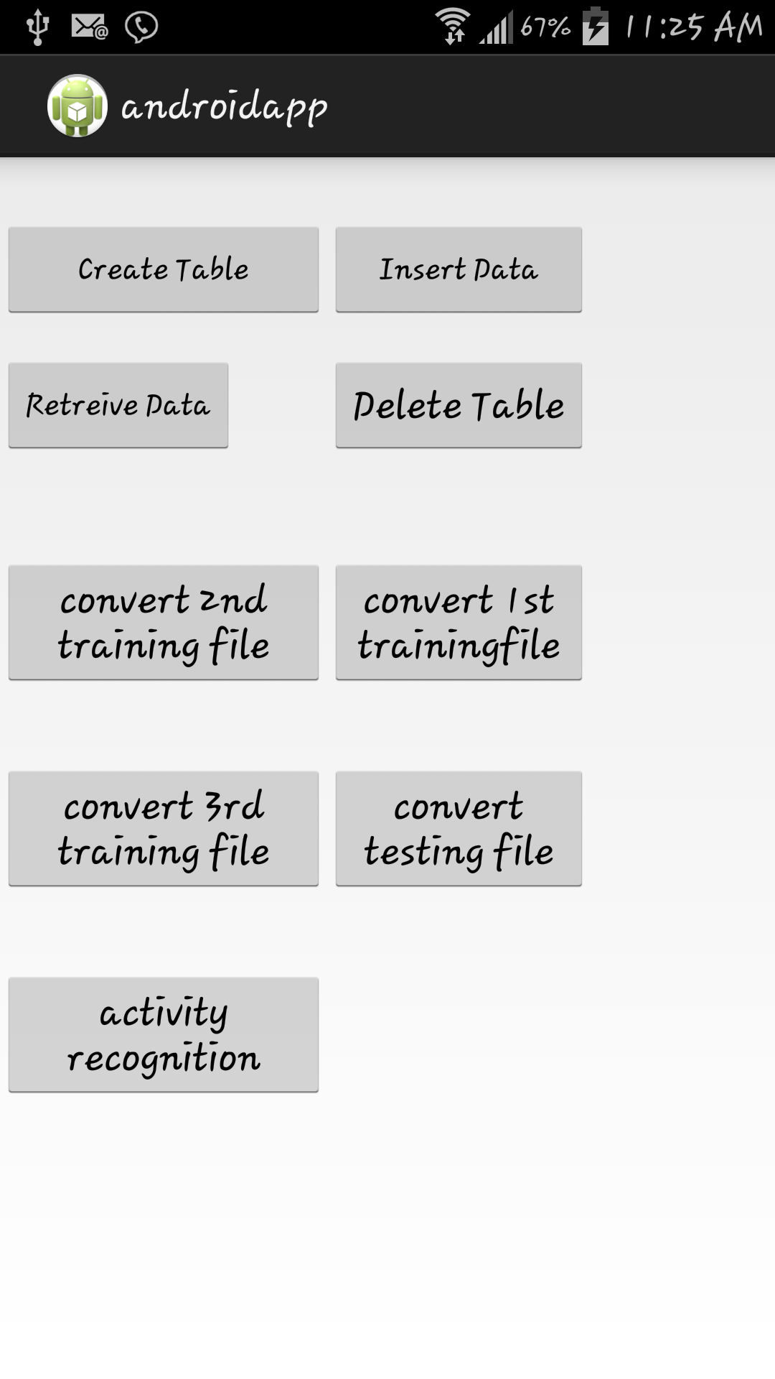

Following screen shot represents the output of training of the first file.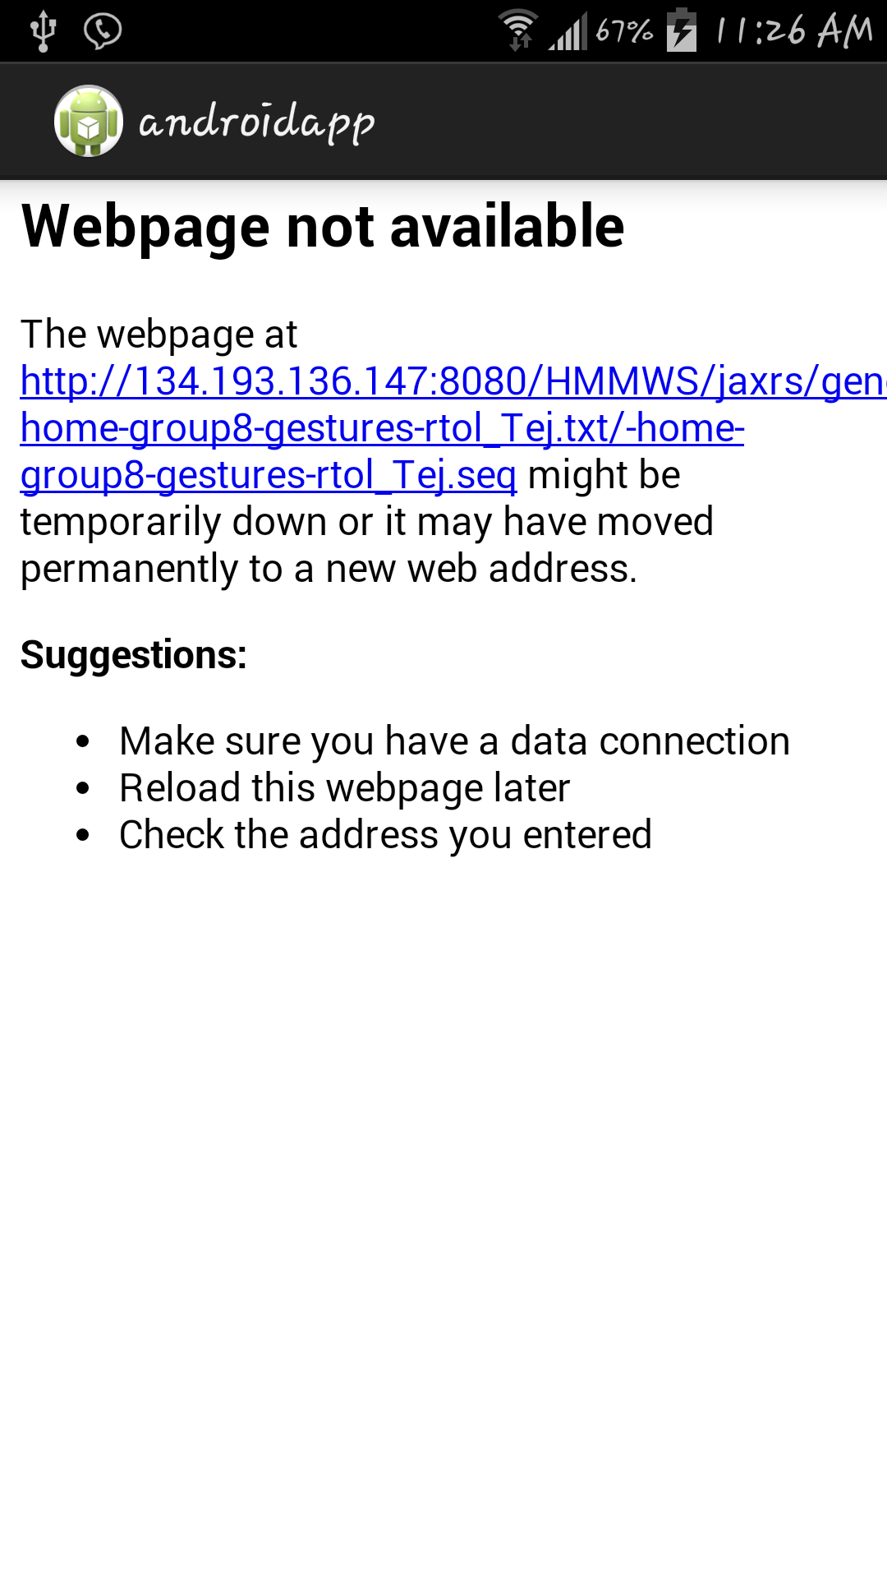

Following screenshot represents the output of the training of 2nd file.  
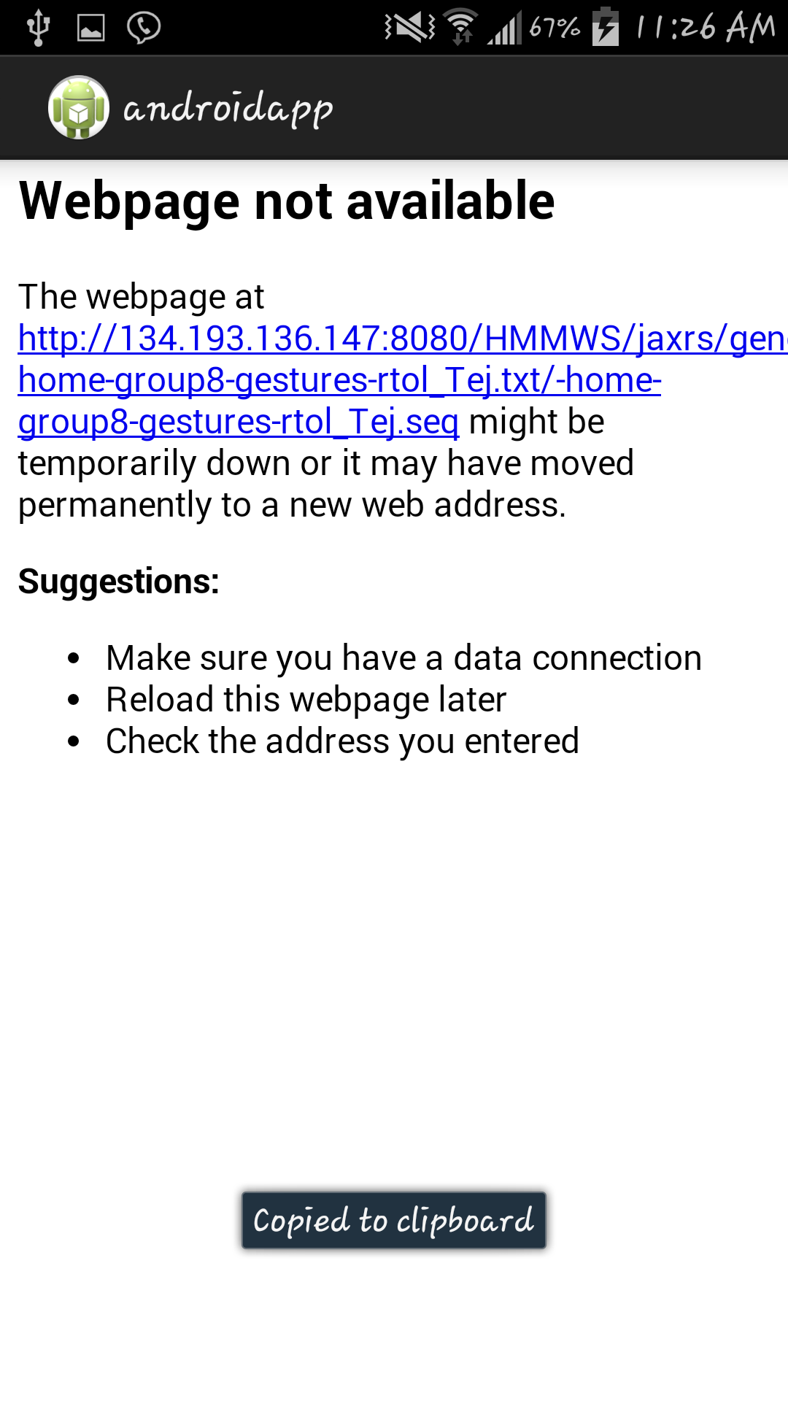

Following screenshot represents the training of 3rd file.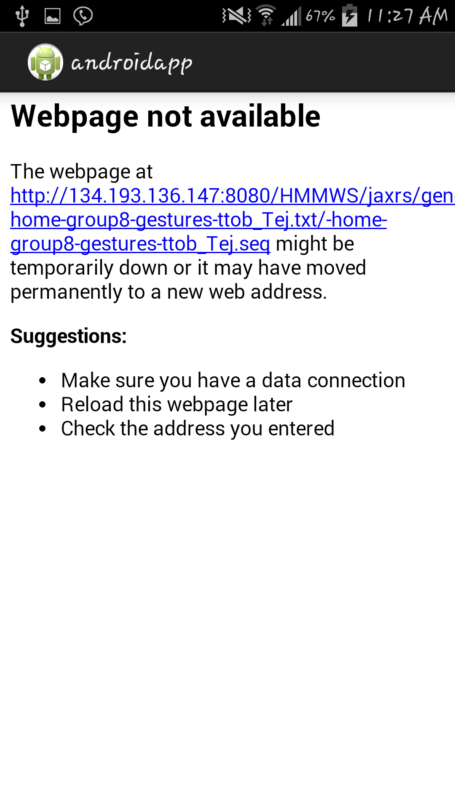

Following screen shot represents the output of the testing of the file.

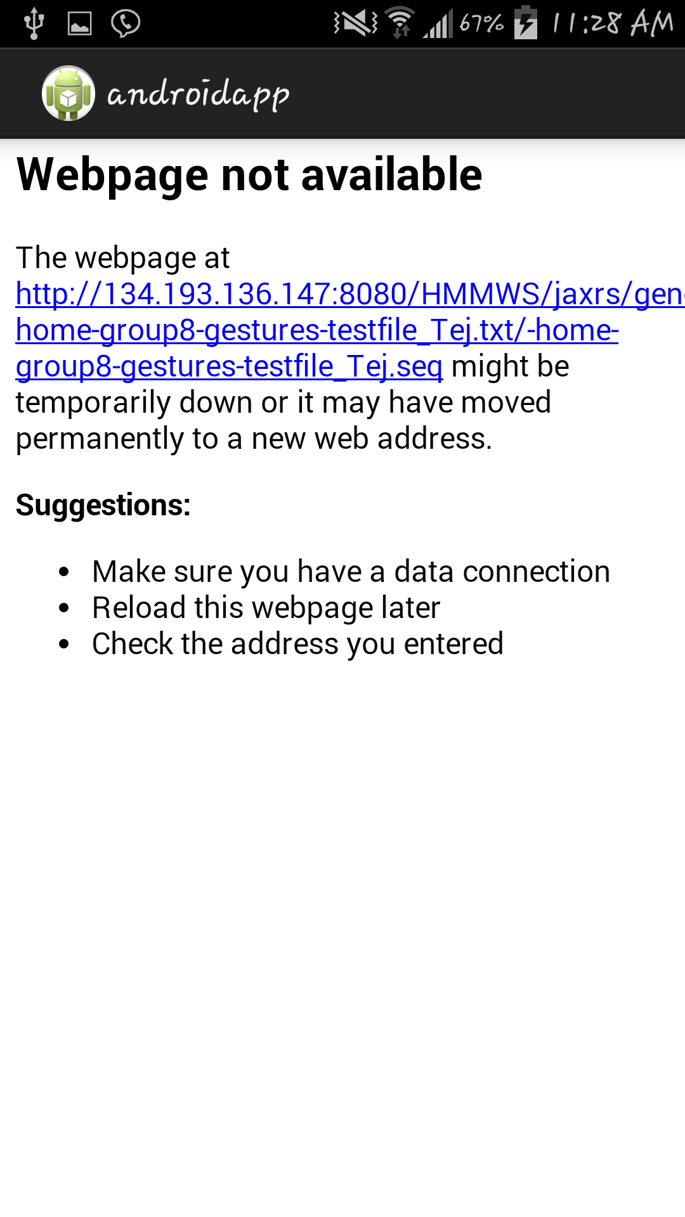

Following screenshot represents the output of the combinational sequence file.

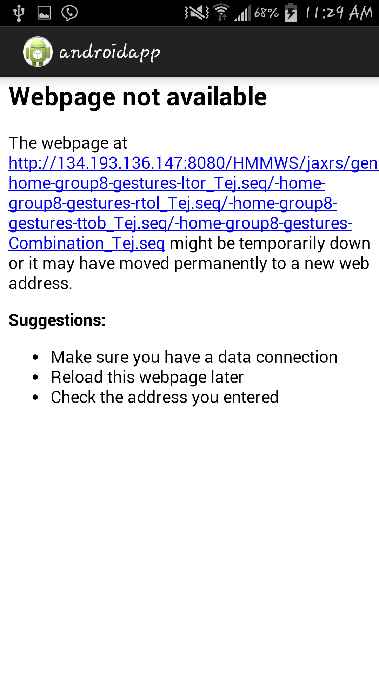

**ISSUES FACED:**

Cloudera VM1 was completely down and the Glassfish server on VM2 is not working. I am unable to retrieve the outputs since the glassfish server is down.